Tail command: print the last 10 data items of the given file

tail filename

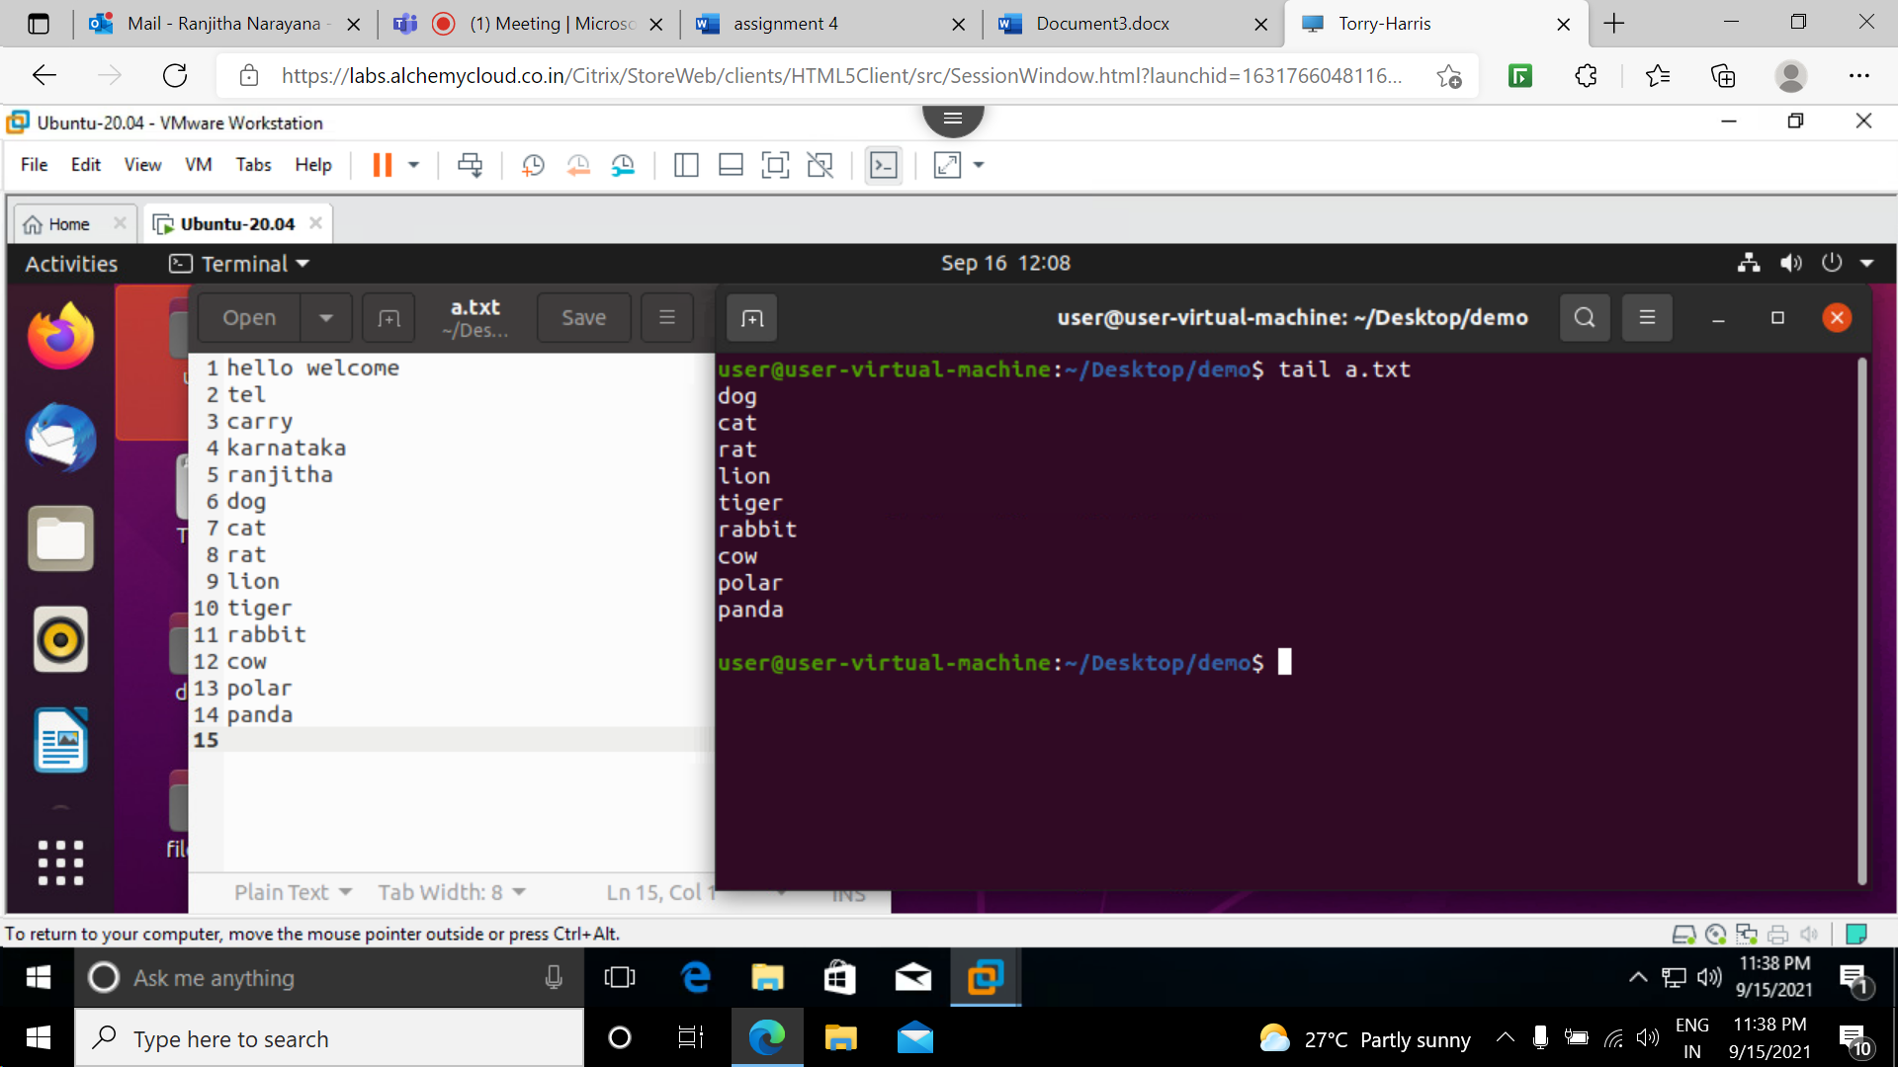

-n prints the last ‘num’ lines instead of 10 lines

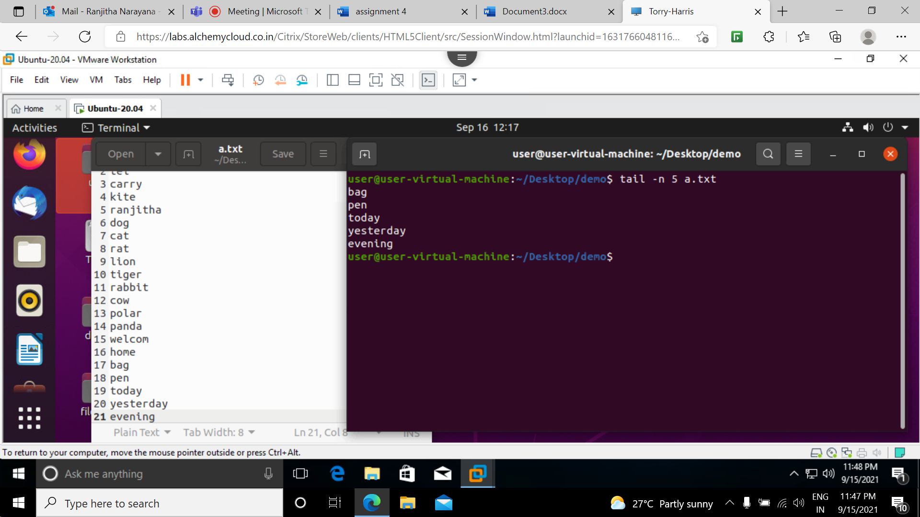

-c : prints the last num bytes from the file specified .

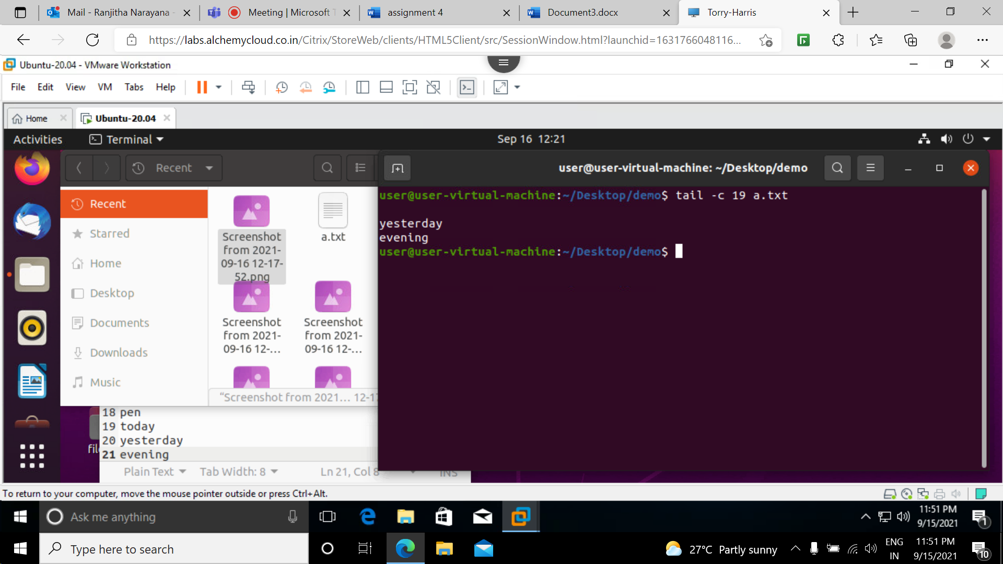

-q : used with more than one file data from each file is not preceded by its filename.

Without using -q

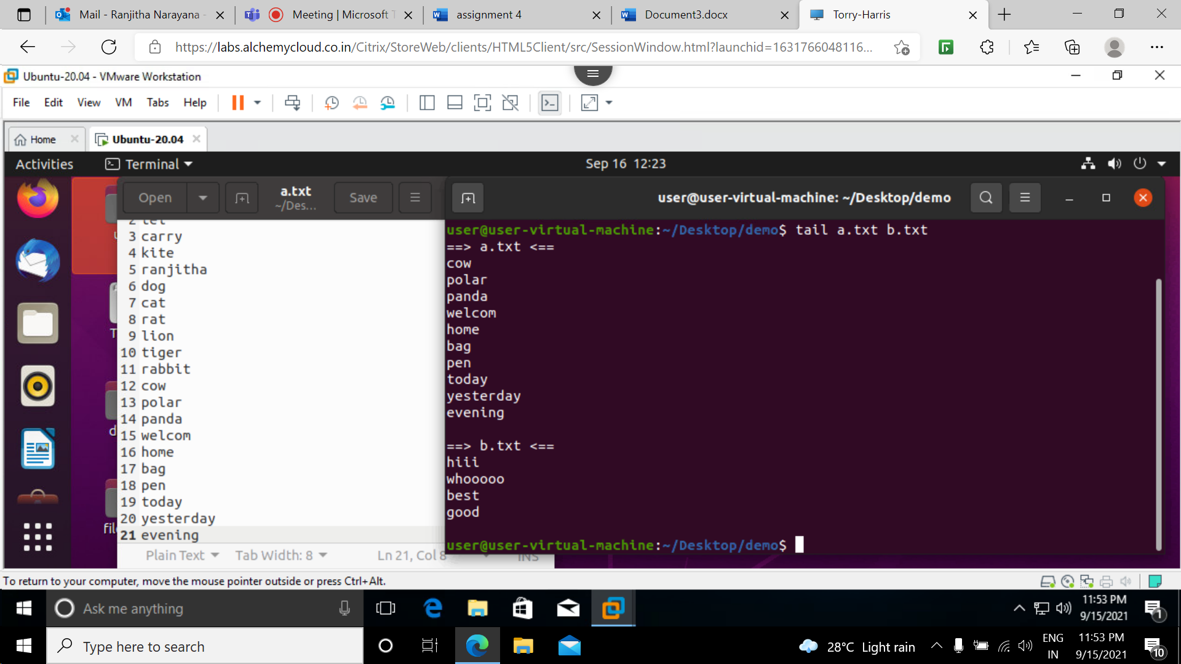

With -q option

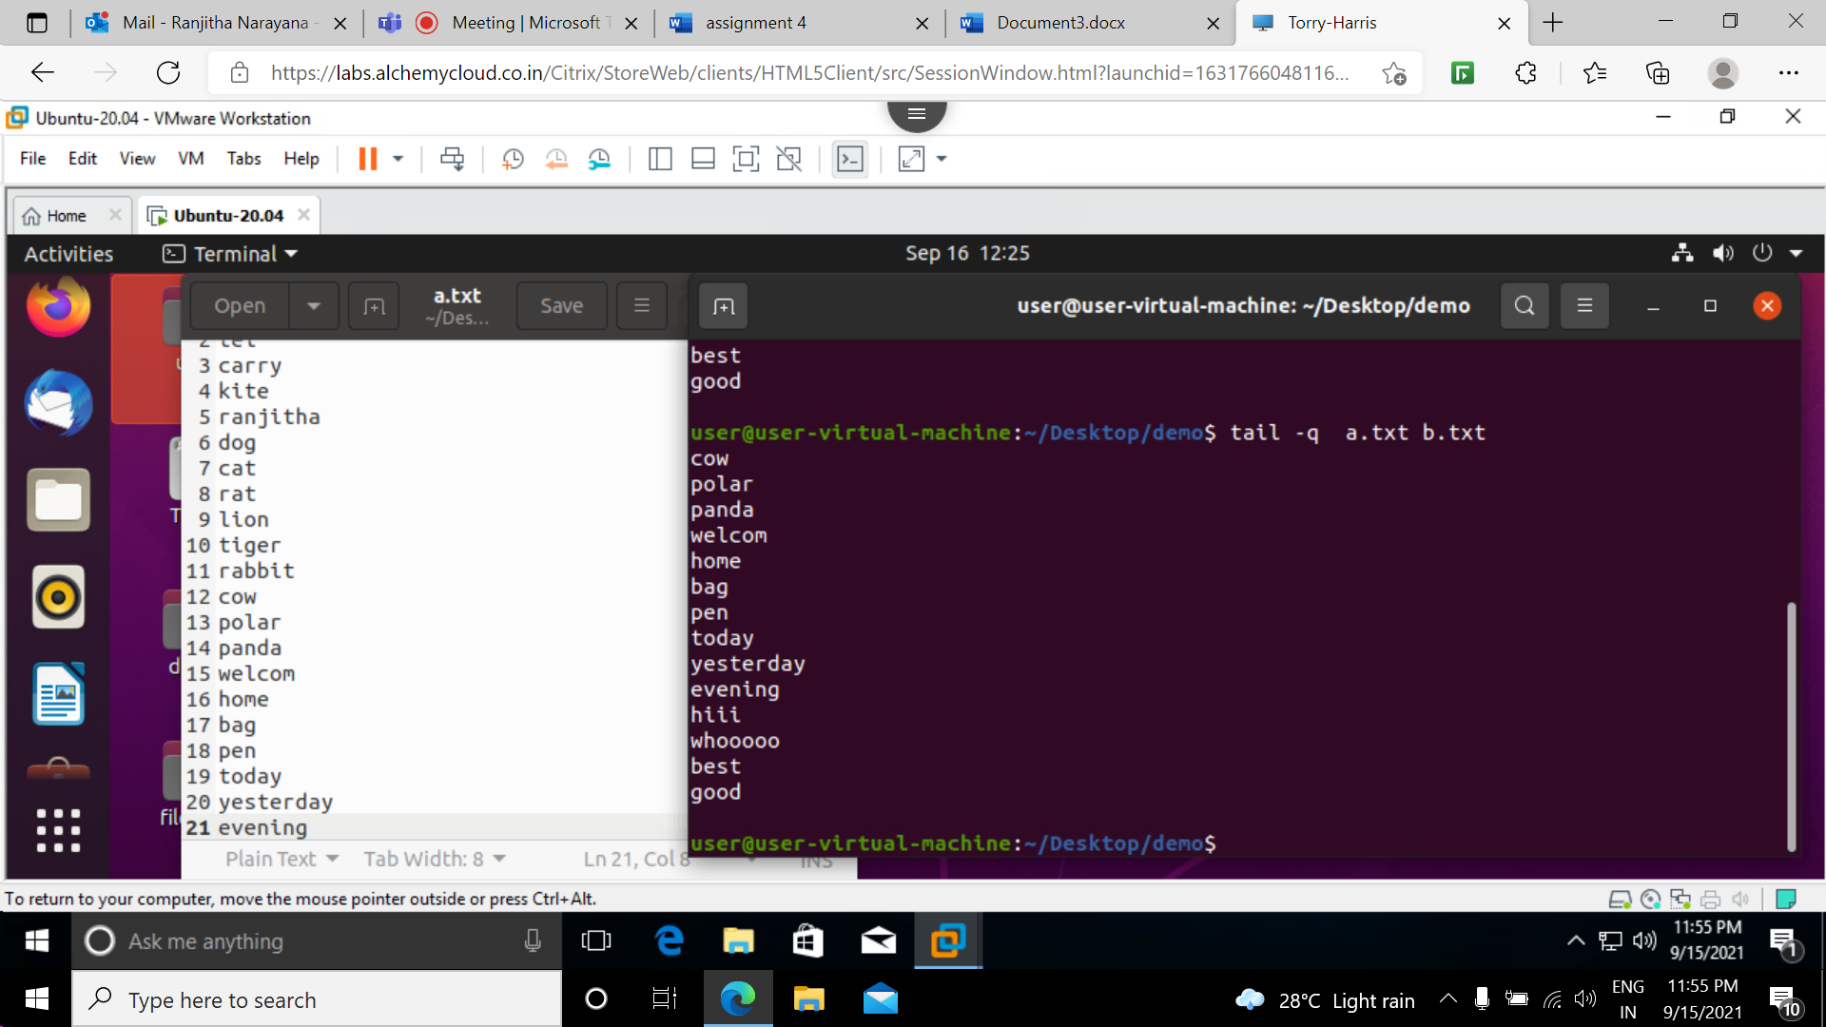

-v by using this option data from the specified file is always preceded by its file name.

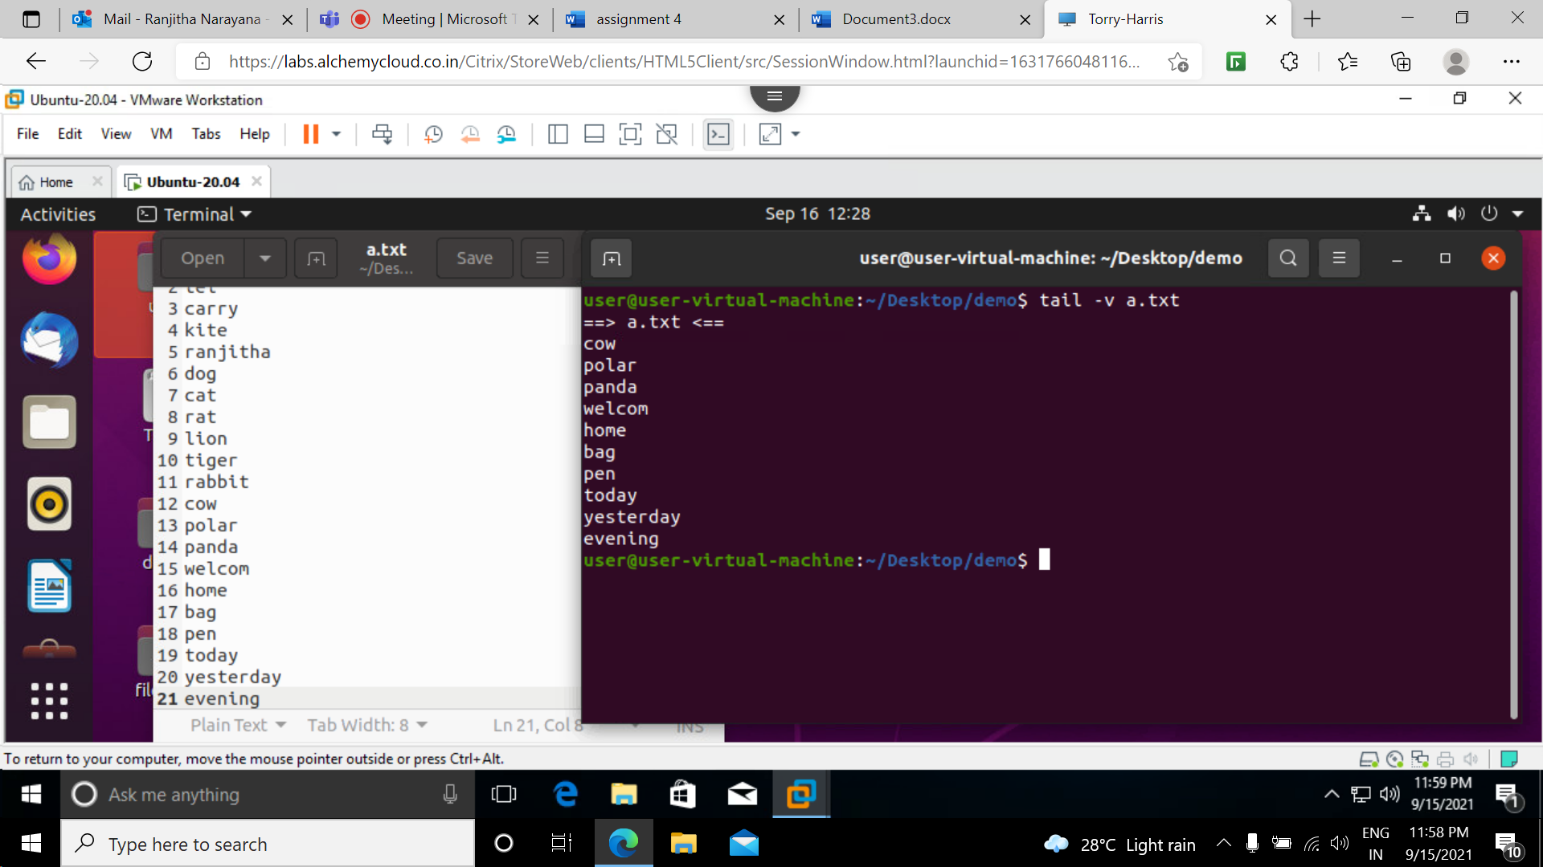

--version :used to display the version of tail

